Chapter 14, Problem 69.

Design the filter in Fig. 14.94 to meet the following requirements:

- It must attenuate a signal at 2 kHz by 3 dB compared with its value at 10 MHz.
- It must provide a steady-state output of v_{o}(t) = 10 sin (2π × 10⁸t + 180°) V for an input v_{s} (t) = 4 sin (2π × 10⁸t) V.

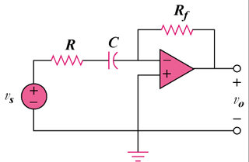

Figure 14.94
For Prob. 14.69.

